**Angeles  City Science High School**

**MAPEH 9**

**Name:** Paul Gerald D. Pare **Section:** 9 - Adenine

Activity 4

Listen to the Classical Music below and answer the questions that follow:

1. G.F. Handel “Halleluia Chorus”
2. Thomas Morley “Fire, Fire, My Heart”
3. L.V. Beethoven Symphony no. 9, Op. 125, D Minor “Choral Symphony no. 9”

**Guide Questions:**

* 1. Describe and differentiate the elements of the 3 compositions.

Halleluia Chorus has higher tone in lyrics but lower volume in music. The Fire, Fire, My Heart however has high tone but not as high as Halleluia and for Choral Symphony, it has higher volume and tone in music compared to lyrics.

* 1. Among the three compositions, which do you like the most?Why?

I personally like the Choral Symphony because it has more vivid and lively music compared to its lyrics.



LET US APPRECIATE (ISAPUSO MO)

## ACTIVITY NO. 3

Think of one symbol either in music or art form that you think will best describe the history of music during the classical period/era. Explain your reason why you choose that symbol in 6 sentences.

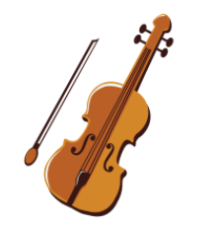 I chose violin, because I observed that in those three songs, they have violin. This symbolizes the high pitch and tone to their songs. Its also much slower compared to modern song. Modern songs tend to be much faster and lively compared to classical songs. Compared to classical and 80’s songs, I noticed that classical tend to have higher tone and pitch where as 80’s have lower and slower pace.